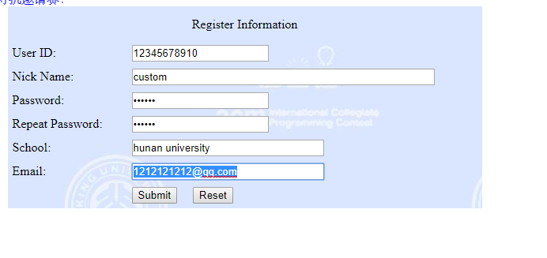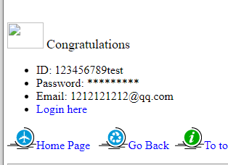http://poj.org/login?user_id1=987654321test&password1=123456

<http://acm.zju.edu.cn/onlinejudge/login.do?handle=123456789test&password=123456>

<http://acm.zju.edu.cn/onlinejudge/showProblemsets.do>